

**Key Word Level Instructions**

**What are they?**

To successfully understand instructions, children need to be able to understand and remember all the **key words**. A key word is a word which MUST be understood in order to carry out an instruction.

For a word to be a key word:

* **There must be a** **contrast** – an alternative which could be chosen instead e.g., doll or teddy, cup or plate, toothbrush or hairbrush. For example, “give me the book” has no key words if the book is the only object in front of the child.
* **No clues are given** - clues include routines, context as well as pointing/looking at target objects. E.g., if a teacher instructs “put your coat on” when other children are putting coats on and while pointing to the coats, the child may not actually have understood the key word ‘coat’ as they could copy others and/or follow the gestures.

**Helpful videos:**

1 and 2 key word level - <https://www.youtube.com/watch?v=u2ldwB0XEB4>

3 and 4 key word level - <https://www.youtube.com/watch?v=HBb6OFc8C3w>

**Examples**

**1 Key Word Level:**

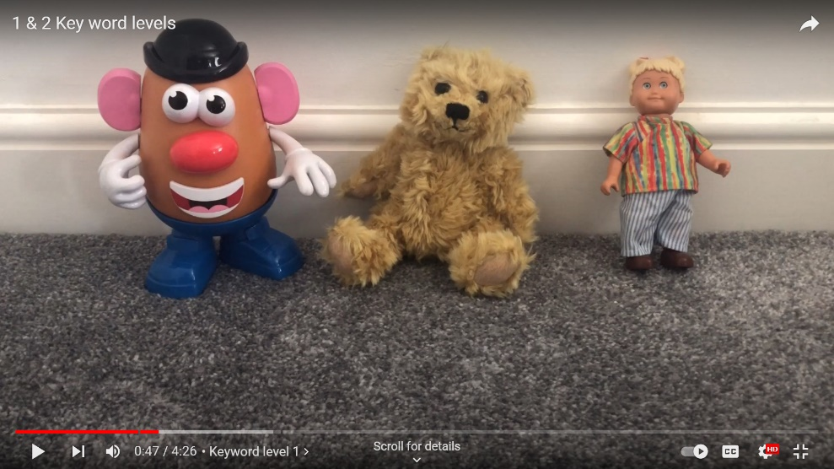 Find the teddy.

* The child has to understand ‘teddy’ because there are contrasting options, Mr Potato Head and a doll.

**2 Key Word Level:**

Find teddy’s eyes.

* 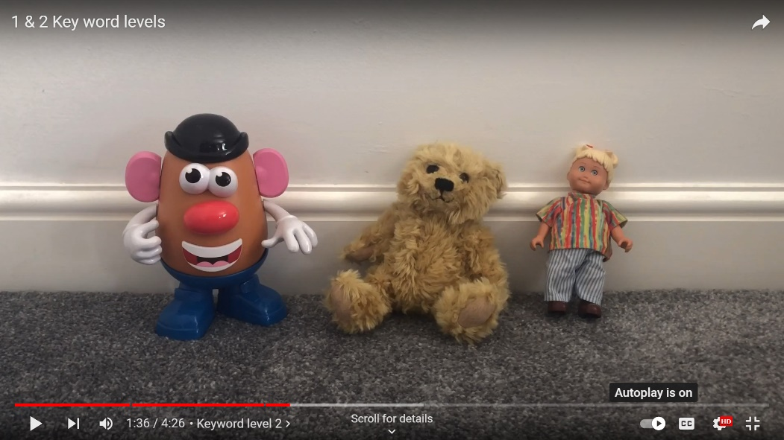The child has to understand ‘teddy’ because there are contrasting toys,
* AND the child must understand ‘eyes’ as there are contrasting options present including nose, mouth.

Make the doll jump.

* The child has to understand ‘doll’ because there are contrasting toys,
* AND ‘jump’ as there are possible contrasting actions i.e., walk, sleep.

**3 Key Word Level**

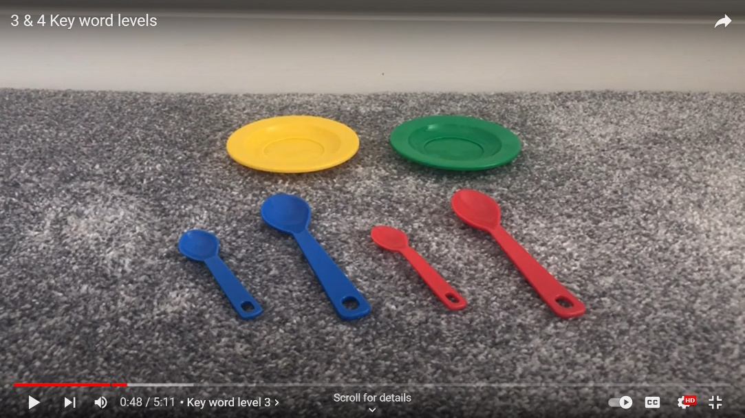 Put the little red spoon on the yellow plate.

* The child must understand ‘little’ as there are big objects,
* AND ‘red’ as there are contrasting coloured blue spoons,
* AND ‘yellow’ as there is also a green plate.

**4 Key Word Level**

Put the yellow fork on the little red plate.

* 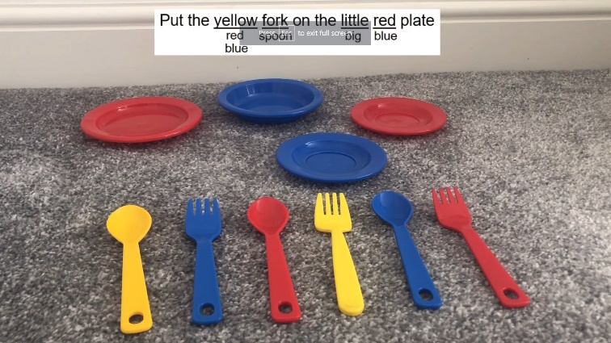The child has to understand ‘yellow’ as there are other colours,
* AND ‘fork’ as there is a contrasting option of spoons,
* AND ‘little’ as there are big options,
* AND ‘red’ as there are other colours.