Intensive Interaction

Used as a therapeutic approach for CYP with limited social and communication skills. The aim is to ‘teach’ the fundamentals of communication.

Key Information

* Needs to be used on a daily basis
* Own environment
* Join in with what the CYP is doing, joining their world and enjoying it with them.
* Team approach- at least four staff to be working with the individual.
* Quality **of the interaction is what is important.**

Techniques

* Sharing personal space- sitting, lying, standing etc
* Vocal Echoing- non symbolic sounds/ vocalisations or breathing patterns
* Mirroring- posture, movements, behaviours
* Physical contact- holding, squeezing, stroking, clapping, hand over hand, touching forehead, rubbing noses etc.
* Making or exchanging eye contact
* Exchanging facial expressions
* Joint focus activity
* Turn taking
* Burst-pause sequence- hide and seek, catch with count down, noise escalation games etc.
* Using ‘running commentaries’ – “wow, great”, “I can see you looking... “etc.

See it in practice!





How to guide

1. 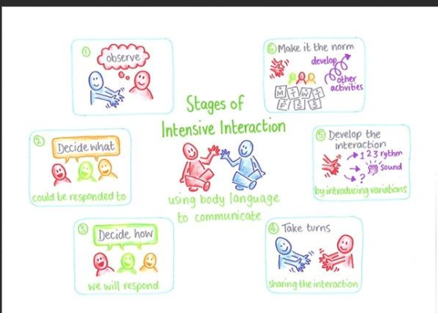Observe CYP. Watch and wait for them to do something you can respond to.
2. Mirror what they are doing. Copy actions, sounds which you feel comfortable to join in with. Ensure staying face to face.
3. Scan for signals they are enjoying it.
4. Ease in turn taking (burst- pause) burst of your behaviour/ action – immediate pause- signalling you expect a response. (you may not always get a response, but you are encouraging them to learn how and when to respond)
5. Interpret their reaction for ‘more’

CYP to lead whenever possible. Creating a conversation without words. Taking turns with sounds, movements or facial expressions

Tips

* Do not jump in with comments or direct in anyway, unless it’s a behaviour you don’t want to encourage.
* Helpful to have 2 of the same toy/ item
* Interaction sequences will vary with intensity- respect change in pace.
* Don’t go in with specific aims other than connecting with the CYP
* Video interactions to track progress (if appropriate)

Things to be aware of

* Physical contact- consent, document it, appropriateness, have others present, know when to be cautious.