Kingsland School


POS
Primary Outreach Service

Supporting Schools, children and

their families.

Kingsland School Primary Outreach Service

Our Service

The Primary Outreach Service is a preventative initiative based in Oldham, designed to support mainstream schools in managing pupils who are exhibiting challenging behaviours or are at risk of permanent exclusion.

POS provides short-term, targeted support with the aim of promoting inclusion and preventing escalation. We work in close partnership with schools and their staff, offering practical strategies and interventions tailored to individual pupil needs.

We recommend that schools consider referring a pupil to POS once in-school strategies — such as quality first teaching and advice or interventions from other professionals — have been implemented, monitored, and reviewed.

Please email s.qureshi@kingslandschool.org for a Referral and Consent Form or click on the link below;

M:\Laurel Bank\Primary Outreach Service\POS Consultation Form June 2025.docx

M:\Laurel Bank\Primary Outreach Service\POS Family Consent Form June 2025.docx

Waves of support
Due to the changing nature of pupils across the authority and the challenges we have been made aware of, the Primary Outreach Service (POS) is adapting to meet these evolving needs.
The levels of support we can provide are outlined below. We encourage all schools to carefully consider the type of support they may require.

Level 1 – Helping Hand Support
POS can offer immediate support and advice toward EHCP applications, signposting to relevant services, or providing schools with recommended strategies to try. This involves a short consultation, and support is provided promptly.

Level 2 – Targeted Support
POS will deliver free behaviour training tailored to the specific needs of the school. POS will also hold drop-in behaviour clinics on-site that all staff can access.
➡ Note: This level of support must be booked in advance by contacting Mrs. S. Qureshi, Service Manager, at S.Qureshi@kingslandschool.org.

Level 3 – Intensive Support
A member of POS will come into the school on up to a 0.5 contract to provide in-depth support, coaching, and to help implement necessary changes.
➡ Note: This level of support is not always available immediately and may require prior arrangement.

.

Level 3 – Intensive Support (Highest Level Support Package)
Our Level 3 support is the most comprehensive and tailored intervention we offer, designed to address individual pupil cases through a structured and collaborative process.

Referral Process:
All Level 3 cases come through a formal referral process by contacting Mrs. S. Qureshi, Service Manager, at S.Qureshi@kingslandschool.org for the referral forms.
Initial Observation Phase:
Once a referral is accepted, POS begins with a two-week observation period, where a member of the team will observe the pupil discreetly at various points across the school day.

Summary Report & Meeting:
Following the observation phase, POS will produce a detailed summary report, which will be shared with the school and family in a joint meeting. In this meeting, POS, the school, and the family will agree on the recommended outcomes outlined in the report.

Coaching & Implementation:
POS will then work in the school for a short, intensive period (up to 0.5 days per week) to coach staff and implement the agreed-upon outcomes. Progress is regularly reviewed with all parties.

Monitoring Phase:
Once significant progress has been made and outcomes are being met, POS transitions to a monitoring phase, where the team will maintain contact with the school and conduct occasional observations across the week for a shorter duration.

Case Closure:
When all parties agree that the outcomes have been successfully achieved and POS has fulfilled the agreed intervention, the case will be formally closed.

Pupils at risk of exclusion (P.A.R.E) Process

Step 1: School Considers Permanent Exclusion (PEX)
- School identifies that a pupil is at serious risk of permanent exclusion.
- School notifies the Kingsland Primary Outreach Service (POS) Manager:
s.qureshi@kingslandschool.org

Step 2: Initiate P.A.R.E. Process
- School is asked to:
Complete the P.A.R.E. Graduated Response Summary
Arrange and hold a P.A.R.E. Person-Centred Review (PCR) meeting

Step 3: Conduct P.A.R.E. PCR Meeting
- School completes the Graduated Response Summary in collaboration with stakeholders during the PCR meeting.
- Representatives from Education, Health, and Care attend to explore all possible strategies to prevent exclusion.

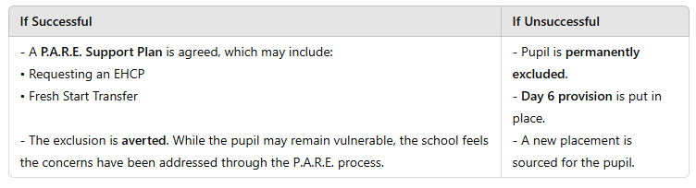

Important
All schools should adhere to this process when they have a pupil at risk of permanent exclusion. Early engagement with POS increases the chance of positive, preventative outcomes.

How to find us

Kingsland School
Laurel Bank Site
Kershaw Street
Shaw
OL2 7AJ
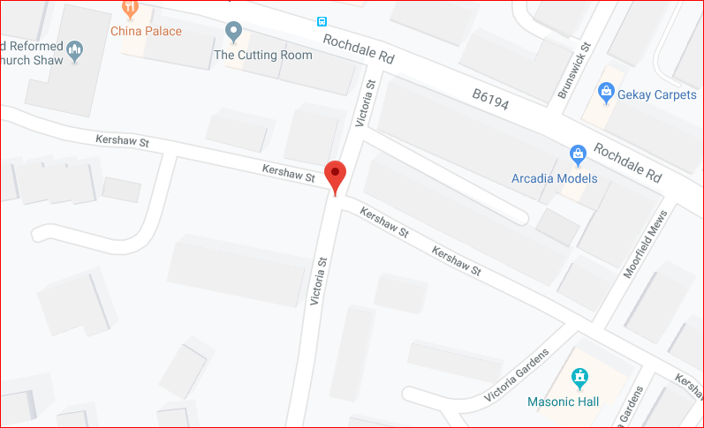
Telephone: 0161 770 7120
Email: Info@kingslandschool.org

