Children’s Speech & Language Therapy (School Aged) Referral Form Guidance

**Please ensure that you have read and understood the following guidance before completing the referral form:**

**Before a referral is accepted, it is expected that the following has happened:**

* A meeting has been carried out between parents and school to share concerns
* Home and classroom strategies have been implemented (i.e. Universal and targeted strategies)

**If the difficulties are impacting on educational progress we need you to show that:**

* There is a SEN (Special Educational Needs) Support Plan/IEP (Individual Education Plan) with specific speech, language and communication targets in place.
* Input has been completed and reviewed by school with parent/carer.

**Expectation around Assess, Plan, Do, Review:**

* Before making a referral to Speech & Language Therapy, which is a specialist service, it is important that you have implemented strategies and interventions at the universal and targeted levels.
* For referrals from school and settings – you will be asked to include dates and evidence of 2 Plan/Do/Review cycles and SEN support plans/IEPs.
* For further information on the Assess, Plan, Do, Review cycle (known as the Graduated Response in Oldham) please refer to the Oldham Council website - <https://www.oldham.gov.uk/homepage/1181/what_is_the_graduated_response>

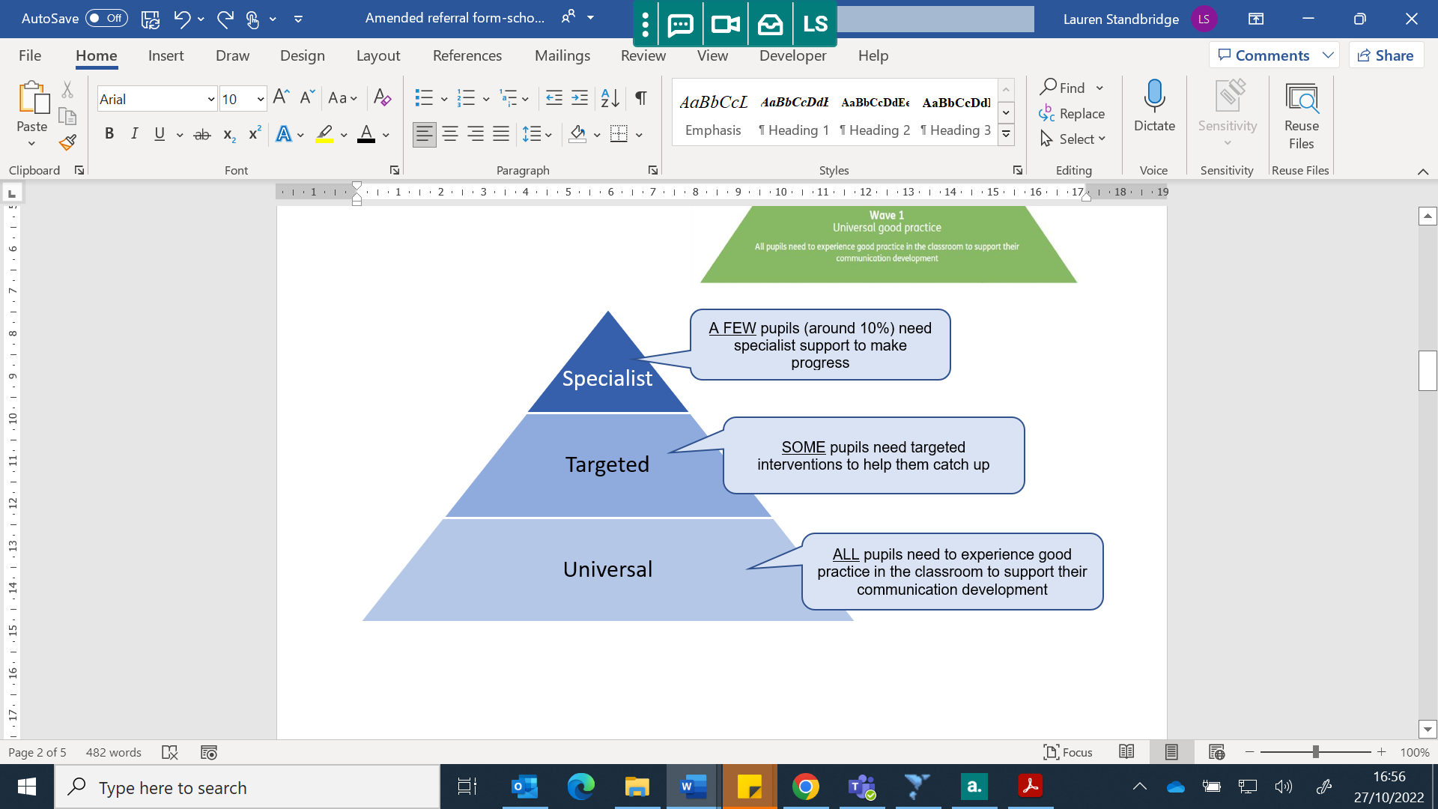

**Children’s Speech & Language Therapy (School Aged) Referral Form**

**PLEASE ENSURE YOU FILL IN ALL SECTIONS OF THE FORM. IF ANY SECTIONS ARE LEFT BLANK OR INCOMPLETE YOUR REFERRAL WILL NOT BE ACCEPTED.**

|  |  |  |  |
| --- | --- | --- | --- |
| **Child’s Name:** | | **Preferred Name/Known As:** | |
| **D.O.B:** | **Gender:** | **NHS no (if known):** | |
| **Address:** | | | |
| **Post Code:** | **Tel. No.:** | | **Mobile:** |
| **G.P. Practice:** | | **G.P. Address:** | |
| **Home Language (please tick):** **English  Mirpuri Punjabi  Bengali  Urdu  Pushto  Mandarin  Cantonese**  **Henco  Romanian  Polish  Arabic**  **Other: ………………………………………** | | **Which is the predominant language spoken at home:**  **Interpreter Required? Yes / No** | |

##### **Parent/Carer Consent:**

**I have read and understood the information in the form below, and I give my permission for this referral to be made. If this referral is accepted, I give my consent for the following (as necessary/appropriate):**

1. **Carry out a speech and language assessment with your child**
2. **Provide speech and language therapy to your child**
3. **Visit your child’s school/nursery**
4. **Share information with other professionals directly involved in the care of your child**
5. **For other agencies to be contacted to gain further information e.g. School, Educational Psychologist, Paediatrician.**

**Parent/Carer Details:**

Name …………………………………………Signature………………….………………………………….

Date…………………………………………Email address………………………………………………….

**Referrer Details:**

Name………………..……………………..……… Role..…………………………………………………….

Signature…………………………………………Contact no…………………………………………………

Address…………………………………………Date of Referral……………………………………………..

**School Details & Other Services:**

School:……………………………………..SENDCo/Named person:……………………………………

Is the child known to the Community Paediatric Service? Yes No

Is the child known to any other services Yes No Details……………………………….

Has the child any other identified additional needs (physical, medical, learning)?…………………………………………………………………………………………………….

Any other relevant medical diagnosis or information (e.g. ASC, genetic disorders, medication, allergies)?

……………………………………………………………………………………………………………...........

Has the child previously been assessed by the Speech and Language Therapy Service?

Yes No

If YES please provide dates and details:………………………………………………………………..

Has the child been seen by an independent Speech Therapist either at home or school?

Yes No

If YES please provides dates and details:……………………………………………………………

**Please TICK which of the following interventions have been used with this child:**

* Elklan strategies/training implemented
* Communication friendly status accreditation
* WELLCOMM Big Book of Ideas Interventions
* Communication champion staff member in place
* Speech and Language training courses by SALT  Please specify which courses/interventions are being used:……………………………………….

……………………………………………………………………………………

* QEST training courses  Please specify which courses/interventions are being used…………………………………………………………………………..
* Any other……………………………………………………………………………………

**Please provide DATES and EVIDENCE of the last 2 Plan-Do-Review and SEN Support Plans/IEPs:**

**Date 1: ………………………………… Date 2:……………………………**

**Evidence included with referral:** Yes No ……………………………………….

**Reason for referral**

Please give a brief **description** **of your concerns** regarding this child/young person’s communication skills: (please consider: spoken language, understanding, attention/listening/play, speech sounds, social communication/ friendships and stammering).

What **impact** do the current difficulties have on the child/young person (e.g. at school and at home)? How does it affect their ability to **participate** in everyday activities?

Please describe any **input** currently used to meet the child/young person’s needs (at school and at home). What **strategies** are in in place to enable the child/young person’s communication?

|  |
| --- |
|  |
|  |
|  |

What **support** would you like from the Speech & Language Therapy Service (e.g. training; resources; assessment; targets/programmes)?

**Thank you for taking the time to fill in this form. All the information above will be considered by an experienced Speech and Language Therapist and a decision made as to the appropriate course of action.**

**PLEASE RETURN COMPLETED FORM TO:**

**Speech and Language Therapy**

**Integrated Care Centre**

**New Radcliffe St**

**Oldham. OL1 1NL**

**Tel: 0161 206 1452**

**Email: childsaltoldham@nca.nhs.uk**

Children and young people who are registered with a Oldham GP and attend a Mainstream Primary or Secondary School, St Paul’s Language Provision or are home educated.