
Preschool Speech & Language Therapy Service Referral
Children’s Speech & Language Therapy Referral Form Guidance
PLEASE ENSURE THAT YOU HAVE READ AND UNDERSTOOD THE FOLLOWING GUIDANCE BEFORE COMPLETING THIS REFERRAL FORM
Before a referral is accepted, it is expected that the following has happened:
- A meeting or detailed conversation has been carried out between Parents and the Referrer to share concerns.
- Prior to referral- the referrer having a conversation with other key agents such as Nursery setting or Health Visitor.
- If this is a self-referral, Parents to share their concerns with Health Visitor, Children’s Centre staff or Nursery.
- All the steps above are to ensure that Home and if appropriate Nursery strategies have been implemented (i.e. Universal and targeted strategies) have been put in place before consideration of referral to SALT.
If the difficulties are impacting on educational progress we need you to show that:
- A targeted plan of support for the child with specific speech, language and communication targets in place.
- Input has been completed and reviewed by school with parent/carer.
Expectation around assessment and reviews.
Before making a referral to Speech & Language Therapy, which is a specialist service, it is important that you have implemented strategies and interventions at the universal and targeted levels.
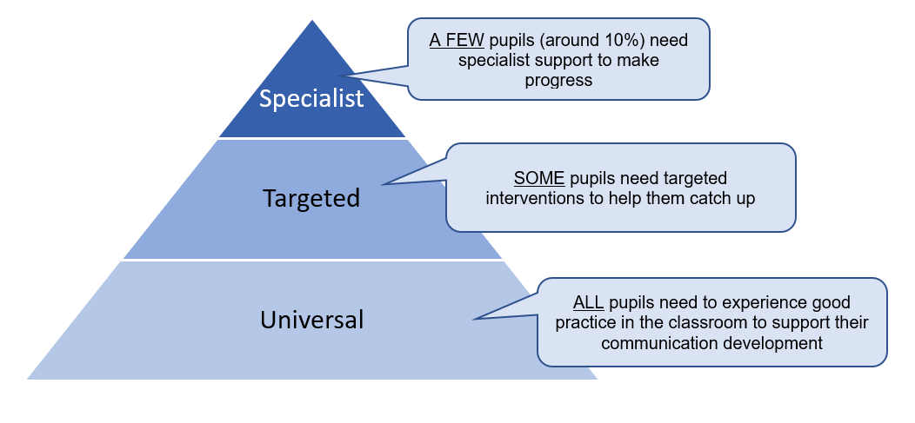
For referrals from school and settings – you will be asked to include dates and evidence of review meeting or 4+1 meetings. Any needs identified through assessment should be targeted using an appropriate tracking tool.

Please fill out this referral will all relevant information and as much detail as possible.
Child’s Name: |  | Preferred Name/Known As:
D.O.B: | Gender: | NHS no (if known):
Address:
Post Code: | Tel. No.: |  | Mobile:
G.P. Practice: |  | G.P. Address:
Child Looked After (only tick if child is formally looked after– not CIN/CPP) ☐
Home Language (please tick): English ☐ Mirpuri Punjabi ☐ Bengali ☐ Urdu ☐ Pushto ☐ Mandarin ☐ Cantonese ☐  Henco ☐ Romanian ☐ Polish ☐ Arabic ☐  Other: ……………………………………… |  | Which is the predominant language spoken at home:  Interpreter Required? Yes / No

Parental permission for referral & assessment/treatment:
I have read and understood the information in the form below, and I give my permission for this referral to be made. If this referral is accepted I also give my consent for the following (as necessary/appropriate):

- Carry out a speech and language assessment with your child
- Provide speech and language therapy to your child
- Visit your child’s school/nursery
- Share information with other professionals directly involved in the care of your child
- For other agencies to be contacted to gain a complete picture of your child’s communication
difficulties Eg School, Additional Educational Needs Service, Educational Psychologist,
Paediatrician.

Carers name ……………………………………………… Signature ……………...…………………………… ………

Signature of referrer .……………………………………. Date ……………..…………………………………….……..

Nursery/Preschool Details:
Name of Nursery/Preschool ………………………………………………………….
Days/sessions the child attends ………………………………………………………..
Contact Person and Tel no……………………………………………………………
Additional Required Information
Is the child known to the Early Years Additional Educational Needs Service? No Yes
Is the child known to the Community Paediatric Service? No Yes
Is the child known to any other agencies, e.g. Clinical / Educational Psychology, Werneth Outreach Team,
Social Services, Physiotherapy, Occupational Therapy, Audiology, Children’s Centres/ Right Start Team? Please give details of input type, whether ongoing/ care ended and recommendations…………………………………………………………………………………………………………..
…………………………………………………………………………………………………………………………………
Please give results of child’s most recent hearing test…………………………………………………………………….
Has the child any additional (physical, medical, developmental) needs?………………………………………………….
……………………………………………………………………………………………………………………………………..
Has the child previously been assessed by a Speech and Language Therapist at home or in setting? Please include NHS drop in sessions information. If YES please give details
……………………………………………………………………………………………………………………………………
Has the child had involvement from an Independent Speech and Language Therapist at home or in setting? If YES please give details………………………………………………………………………………………………………………….
Are there any other members of the child’s family who are currently receiving, or have previously received Speech and Language Therapy? If YES please give details………………………………………………………………………..

REASON FOR REFERRAL

Please complete this checklist with parents/carers.
- Tick either ‘developmentally appropriate’ or ‘cause for concern’ on each line for the child’s chronological age and the age just below.

DEVELOPMENTALLY APPROPRIATE | POSSIBLE CAUSES FOR CONCERN

BY 18 MONTHS
- Able to share attention jointly with adult, e.g. looking at the same books and toys together | - Unable to share attention with adult, e.g. unable to look at the same books and toys together
- Short attention span | - Only able to attend to activities for a few moments
- Understands and anticipates daily routines and familiar events | - Persistent difficulty coping with new routines/ situations / sudden changes
- Responds to simple commands, questions as part of everyday routines | - No understanding of very familiar, often used words  - Little response to any spoken language
- Understands other’s simple gestures and facial expressions | - Unable to interpret simple gestures or facial expressions
- Communicates needs and feelings through non verbal language, (gestures, meaningful eye contact, facial expression) rather than through words | - Unable to make any needs and feelings known  - Does not demand much adult attention  - Does not point to request things.  - Does not point to show and share interest in things
- Enjoys two way interactions, e.g. early turn taking games, early conversations | - No interest in two way interactions with others
- Babble, jargon or words which family understand | - No babble or words
- Functional play, (using toys/objects as they were intended), some early pretend play | - No functional play.  - No early pretend play

BY 2 YEARS
 | - Able to concentrate for short spells | - Does not sustain attention span even on a chosen activity
 | - No concerns about understanding of familiar language. Can respond to simple instructions | - Little understanding of the names of everyday objects and actions  - Only able to follow instructions in familiar routines
 | - Uses a small number of words (10-20), possible ‘nonsense’ words | - Using very few recognisable / meaningful sounds or words
 | - Only close family understands speech | - Few or no words understood by close family
 | - Good pretend play | - Little pretend play
DEVELOPMENTALLY APPROPRIATE |  |  | POSSIBLE CAUSES FOR CONCERN
BY 2 ½ YEARS
- No concerns about understanding of language, understands a range of instructions | - Does not seem to understand what is said to him/her
- Single word vocabulary of 30+ words and parent reports progress | - Says only a few/no words though other skills are good, e.g. attention, understanding, play. Not linking words at all
- Speech is often difficult for people outside the immediate family to understand | - Speech is often difficult for mother/close family to understand
 | - Has a stammer
 | - Reluctance to talk
BY 3 YEARS
- No concerns about understanding of language | - Does not seem to understand what is said to him/her
- Uses appropriate sentences of 3+ words | - Only uses single words  - Uses the same phrases over and over again  - Uses inappropriate short sentences
- Close family usually understand what child is saying  Often unintelligible to others | - Speech is difficult for family to understand most of the time
- Welcomes and responds to adult suggestions much of the time | - Hardly ever responds to adult suggestions during play  - Cannot attend for longer than a few minutes
 | - Has a stammer
 | - Reluctance to talk
BY 3 ½ – 4 YEARS
- No concerns about understands most of what is said to him/her | - Does not seem to understand what is said to him/her
- Utterances are 5 – 6 words long and used appropriately | - Not using 5-6 word utterances
 | - Hardly ever responds to adult suggestions in play
 | - Repeats the same phrases over and over and/or mimics others’ language frequently
 | - Uses unusual word order
- Speech is mainly understood by others | - Speech is mostly difficult for others to understand
- Sounds f, v, s, z, sh used but not always pronounced correctly | - Never uses sound group f, v, s, z, sh
- Sounds t and d used for c/k and g | - Does not use final consonants in words  e.g. book = boo  - Uses k and g for many other consonants  e.g. door = goor, sun = gun, shoe = gu
 | - Has a stammer
 | - Has an habitually hoarse voice
 | - Reluctance to talk

IMPACT OF COMMUNICATION DIFFICULTIES

You must also fill in each of the boxes below, giving as much detail as possible. This information is crucial in helping us decide whether or not to accept the referral. Please circle ‘yes’ or ‘no. If ‘yes’ please explain further.

1.) Does the child’s difficulties affect their ability to carry out activities they want to e.g., supermarket trips, trips to the park, playing with friends? YES/ NO (If ‘yes’, please provide examples)

_____________________________________________________________________________________

_______________________________________________________________________________________

2.) Can the child communicate their basic needs? E.g., can they request their favourite toy? Can they ask for food and drink? YES/ NO (If ‘no’, please provide examples of how the child requests)

3.) Have the child’s parents or anyone in the child’s environment (e.g., in nursery or home) received any advice, remote or face to face training in communication strategies? YES/ NO (if ‘yes’ please specify course and an year of attendance)

4.) Is the child having a negative emotional response as a direct consequence of their communication difficulty e.g., tantrums, avoiding speaking etc? YES/NO (If yes, please give examples)

PLEASE RETURN COMPLETED FORM TO:

Oldham Community Health Services
SPEECH and LANGUAGE THERAPY SERVICE
INTEGRATED CARE CENTRE
NEW RADCLIFFE STREET
OLDHAM OL1 1NL
Tel: 0161 206 1452
Email: childsaltoldham@nca.nhs.uk

Please fill in the table below to indicate which services the child has already been recommended and/or has accessed. If families haven’t received universal service input, this should be put into place prior to referral.

Services | Has this been recommended | Has this been attended?  Please provide information and dates of attendance
WELLCOMM assessment

WELLCOMM input sessions/ advice
WELLCOMM reassessment following input
ICAN
input sessions
Babbling Babies

Children’s Centre
Little Talker advice
BLAST

Elklan activities
Stay and Play sessions

Nursery setting

Solihul Parenting Programme
REAL (Raising Early Achievement in Literacy)
Review meetings e.g. 4+1
Other (please specify)

What progress has the child made since attending the above service(s)?

PLEASE FILL IN ALL REQUIRED DETAILS TO ENSURE THAT REFERRALS CAN BE FULLY CONSIDERED

