Phonological Awareness

Phonological awareness helps children to recognise words that are part of their home language, to hear the difference between words, and to correct their own speech sounds errors.

Children who have delayed or disordered speech sounds development often have poor phonological awareness. This means they find the following things difficult:

* Knowing when one word ends and another begins
* Splitting words into syllables
* Naming the first and last sounds in a word
* Hearing the difference between similar sounding words
* Changing sounds to make new words.

**Before starting with the below activities, please first check your child’s understanding of ‘same’ and ‘different’.**



**You could line up some objects (counters, coins, figurines etc) and ask your child to point to the following:**

* Can you show me two that are the same?
* Can you show me one that is different to this one (adult points to one)
* Can you show me one that is the same as this one (adult points to one)
* Can you show me the odd one out?

# Noticing Rhyme

Rhyme is a great way to get children having fun with language. Listening for rhymes helps children to be more aware of sounds in words. Rhyming is also a really important skill for reading and spelling.

Children learn to *recognise* rhyming words first and make up their own rhymes later. It is important to remind children to not **think too much about the spelling**, as ‘bye’ and ‘tie’ are still rhyming words!

## Activity 1: Feely Bag/ Box



Collect a few objects that rhyme and place them in a bag or box. Start with around 4 objects at first (two pairs) and name the objects. Once they are all out, encourage the child to match each object to its rhyming pair. You may have to match your pair first, leaving only one choice for your child, but they will soon get the hang of it! You can then increase the amount of objects or pictures to put in the bag/ box!

## Activity 2: Odd one out

Place a set of 3 pictures in front of your child (2 rhyming words and 1 non-rhyming word). Name each picture and emphasise the rhyming part of the words. Explain to your child that two of these words sound the same and one is the ‘odd one out’ because it has a different end chunk (you could make a little posting box for them to put it in). Ask your child to listen to you say the words, and to select the ‘odd one out’.

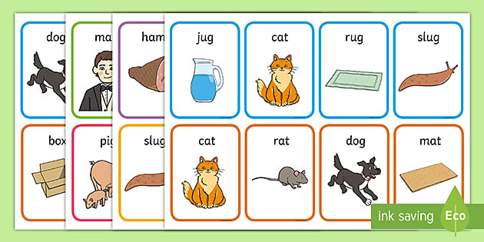

Some word sets you can use include:

hat – bat – scarf tree – bee – flower

car – star – bus pen – men - paper

house – mouse – cat train – bus - rain

**General activities:**

You can also teach your child about words that rhyme during other day-to-day activities using the following:

* Nursery Rhyme books, poetry books, songs and story books with patterned rhymes e.g. Hickory, Dickory, Dock…
* Recorded music, songbooks and songs with actions.
* Collections of ‘tongue twisters’ and books that play with language e.g. ‘Peter Piper picked a peck of pickled pepper…’ or ‘The Cat in the Hat’ by Dr Seuss.

When reading a short rhyming poem or story, try pausing before the next rhyming word and see if your child can tell you what comes next!

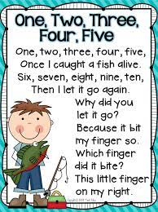

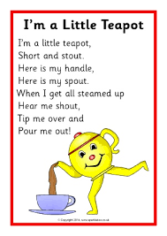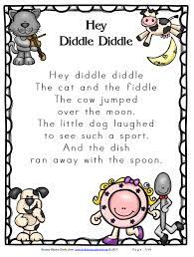

Making Rhymes

Once your child can spot rhyming words easily, support them to make lists of rhyming words. These can be real words (e.g. cat, bat, sat, hat) or nonsense ‘alien’ words (dat, lat, tat, nat).

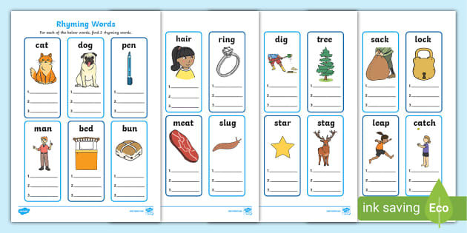

* Play ‘**I Spy’**, but give a rhyming clue instead of a sound clue, e.g. I spy something that rhymes with ‘wall’ (ball).
* “**What am I thinking of**?”: Put a selection of objects in front of your child and tell them you are thinking about one of them. Give them rhyming clues to choose the correct one, e.g. I am thinking of the one that rhymes with ‘ten’ (pen); I am thinking of the one that rhymes with ‘pup’ (cup).
* If your child finds this stage difficult, give them lots of real and silly word examples to listen to, for example “Ten, Ben, Len, Ken, I am thinking of the word…. (Pen!)” or “Pup, Tup, Mup, Sup, I am thinking of the word… (cup!)”

Please contact the Speech and Language Therapy service for any support needed on **0161 206 1452.**