Annual Review of Education, Health and Care Plan
Child/young person’s views

This can be presented in a different format if the child/young person wishes

My name is:

People who are important to me
Family

Friends

Me

Education Provider
Other people who help me

What are my interests / hobbies outside of school / education ?

Things I have liked this year


Things that have helped me this year

Things I have found hard this year

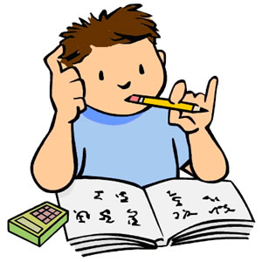
The best ways to support me

Things I would like to achieve next year



One day I would like to………

Signed_________________________ Date___________________________

