# **Ensuring an anxiety-reduced environment for ‘quiet children’ who are reluctant to talk**

# – adapted from Maggie Johnson 2016

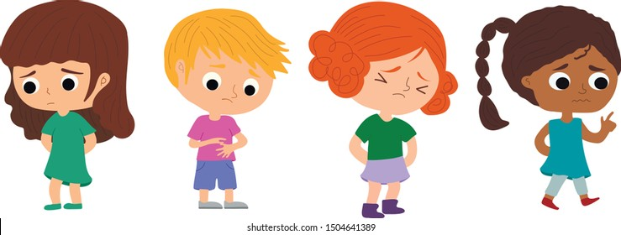

**PLEASE DO:**

* Remember that this is a genuine difficulty and any pressure to speak will make things worse. Have patience and let the child speak when they are ready.
* Engage the child through physical activities, creative projects and fun.
* Talk to the child about what you are doing without expecting an answer. Make comments rather than asking direct questions, eg ‘This looks like your dog, I can’t remember his name though’, rather than ‘What’s the name of your dog?’
* Provide the opportunity to speak rather than making demands, eg ‘Hmm, I wonder where this one goes?’ (pause); ‘Oh dear, I can’t find any round ones’ (pause).
* Warmly respond to the child’s attempts to communicate through gesture or whispering, by talking back in a natural way as if they had spoken.
* Ask the child questions through other adults or children they talk to, keeping a comfortable distance until the child can talk easily in front of you.
* Reassure the child in private that you won’t single them out in class to answer a question, read aloud or demonstrate an activity unless they let you know that they want to be chosen. Say that they can start talking as soon as they feel ready but, until then, just have a good time! It’s OK to laugh and it’s OK to sing – whatever they feel they can manage.
* Invite the child to let you know if anything is upsetting them, or if they have news they want to share, through a two-way liaison book with home.
* Assist transitions between home and other settings: e.g. parents participate with the child in other settings; staff or friends visit the child’s home.
* Try to find time at school for periods of unpressured one-to-one interaction.
* Encourage the child to sit, work or play with friends they talk to in other settings.
* Organise activities in which children move, sing or talk in unison, and activities and games which do not require speech, making this clear before you start.
* Include the child in other activities by offering alternative forms of communication

as a temporary stepping-stone while the child is having difficulty speaking; for

example, pointing, holding up a picture, writing, or recording their news at home.

* Provide opportunities to talk in situations that are less threatening to the child. For

example: ‘Can you take [new child] to the pegs and show her where to put her bag?’;

‘Take Mummy to the hall and show her what we’ve been making for assembly’; ‘Please

help [less able child] tidy up. He’s not sure what he’s got to do.’

* Actively support friendships with other children, making sure that peers don’t pressurise

the child to speak and understand that they will speak in their own time.

* Ensure that the child can access the toilet, meals, drinks, help and first aid without

speaking. Agree a procedure to follow when they feel ill or upset.

* Let children sit at the back or side of the classroom so that they have a good view of goings on in the classroom.
* At registration, allow hands-up, involve the whole class in a social activity, or ask ‘Is

[each child’s name] here?’, so that the class members look around and answer in

unison.

* Let the child know how well they are doing by noticing them being helpful, kind,

thoughtful, hard-working, good-humoured, brave and creative.

* Encourage independence and ensure success. Rather than doing things for the child, do

things with them initially and then withdraw or make things easier.

* Have the same expectations for good behaviour as for any other child.
* Be hurt or offended when the child remains silent.

**PLEASE DO NOT:**

* Confuse a fixed facial expression with glaring, defiance, being uninterested or smirking.
* Bribe, persuade or challenge the child to speak, or make it your mission to get them to talk.
* Make the child say ‘Hello’, ‘Please’, ‘Thank you, etc. They are not being rude.
* Ask direct questions which put the child on the spot, especially when other people are watching and waiting for an answer.
* Look directly at the child when you are hoping that they might say something. It is often helpful to look busy with something else or continue playing whilst waiting for a possible response.
* Penalise the child for not talking or tell them that they are talking too quietly.
* React when the child finally talks. Simply carry on as if they have always spoken, responding positively to what they say, rather than the fact that they spoke. Later you can remark on how much fun you had, how good they are at reading, etc.
* Make the child repeat themselves in public if you don’t hear (it’s great that they are talking at all!). Do say in private, ‘Sorry, I don’t understand’, or ‘That was a great try but I’m sorry, I didn’t hear’, or ‘Did you say X or Y?’.
* Tell the child off in public – have a quiet word in private about your expectations.
* Treat the child too delicately – they enjoy jokes and banter the same as anyone else!
* Follow opting out with special treatment or privileges because this can delay gradual participation.
* Anticipate the child’s every need. Instead, hold back, give permission (‘It’s OK to …’) and create opportunities for them to start taking the lead.
* Object if the child talks to you through their friends – they could be valuable allies in the child’s intervention programme. But do make sure that the child is comfortable enough to communicate with you non-verbally when needed. For example, they could confirm you heard their friend correctly by nodding or shaking their head.
* Be afraid to say ‘Hey, please can you keep the noise down!’ as necessary.
* Be surprised if the child looks confused, does the wrong thing or does nothing. Anxious children are often too tense to process information quickly or accurately, so repeat your instructions quietly and calmly.
* Spring surprises on the child; instead, prepare them for changes and transitions with photographs, visits and visual timetables.
* Allow the child to become isolated. Actively foster friendships with peers, both in and outside school through games, shared projects, interests and activities.

**Further signposting:**

* TOG Mind - Tameside, Oldham and Glossop Mind provide a variety of services for children and young people (aged between 8-18) suffering from anxiety - <https://www.togmind.org/youth-in-mind/take-5>
* SMIRA - SMIRA is a well-respected charity set up to support families with children who are struggling with Selective Mutism (anxiety around talking).

If you have ongoing concerns about a child following implementation of the above advice (for at least one school term), or the child is withdrawing further from everyday activities please contact the Speech & Language Therapy office on 0161 357 5119 and a member of our team will be happy to provide further advice.