**Useful Resources & Training**

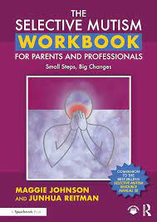

**The Selective Mutism Workbook**

**for Parents and Professionals:**

**Small Steps, Big Changes**

**Paperback – 31 May 2023**

**Available on Amazon for approx. £25**

This workbook provides hands-on Activities, Strategies, planning sheets and progress trackers for use with children with selective mutism at home, at school and in the wider community. Written by selective mutism expert Maggie Johnson and parent coach Junhua Reitman, the workbook includes first-hand accounts of how children can overcome SM successfully using the Activities and Strategies described in this book. Activities are organised around the daily routines of school and family life and each Activity is broken into a progression of small steps with appropriate Strategies and an accompanying record sheet to track progress.

**Free Selective Mutism Training Packages (for Parents/Carers or School Staff):**

* Kent Community NHS Trust - <https://www.kentcht.nhs.uk/childrens-therapies-the-pod/speech-and-language-therapy/selective-mutism/>

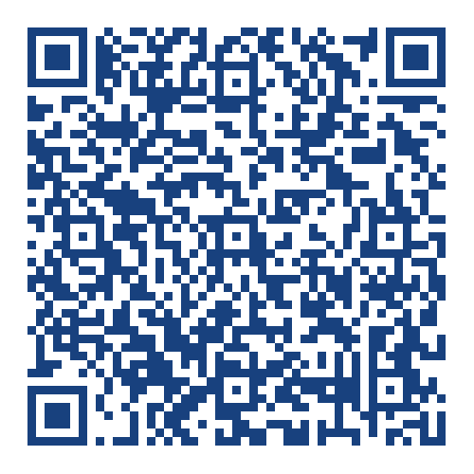

* SMIRA recommended training with resources - <https://servicesforschoolsnortheast.org.uk/Page/28841?fbclid=IwAR1RWtG9EaGGT4Y8iD87sibB2g5fgyiZS1xQ1R-ligSCRtaYvACxx7eEMfg>

