**Alternative Provision**

We have produced a central register of Oldham’s quality assured Alternative Provisions.

**Secondary Alternative Provision**

Dream Big – 17 Cobden Street, Chadderton, OL9 9LE

* Alternative Provision offer provides young people with a high-quality, tailored and inclusive learning experience. We have the capacity to deliver part-time provision to primary school and secondary school pupils as we aim to support their development, confidence and skills in a supportive environment with fully qualified tutors. <https://dreambigsports.co.uk/>



Home of My Education – Greenfield, Saddleworth

* Offers age 4-12, Maths and English tutoring.  Phonics, Sensory processing.
* Emotional regulation- the Zones of Regulation- this can be adapted/ personalised and is currently very art based. Social and communication intervention, Lego therapy.
* Targeted interventions based on EHCP outcomes. <http://www.homeofmyeducation.co.uk>

Compass Forest School – Tandle Hills

* Therapeutic Alternative Provision supporting Primary SEMH children to better manage school in 90 days through Forest School.
* Forest School is a weekly program of woodland free play where children learn life skills, like we used to.
* Compass Forest School offers a given child 10 hours a week of small group therapeutic Forest School split equally over two days.  <https://www.compassforestschool.co.uk/>

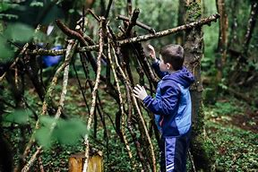

**Primary Alternative Provisions**

Teenage Kicks Partington Street, Failsworth, M35 9RD

Our school, situated in Failsworth, intends to meet the needs of all young people that have perhaps needed a change from a mainstream education. We offer SEMH support and a fresh start to each pupil’s journey and provide a holistic approach in doing so. Teenage Kicks offers an array of subject areas whereby pupils can obtain qualifications and have opportunities to develop and progress to their maximal potential.

We offer vocational elements within our curriculum, giving pupils experience and a focus to progress at post-16. Vocational aspects to our curriculum include woodwork, barbering and hairdressing and photography. <https://teenagekicks.uk/>

Saddleworth Cookery School – Diggle, Saddleworth

Pupils KS3 & KS4 Develop self-confidence whilst cooking, progressing to improving cookery skills and, if appropriate working towards and achieving vocational qualifications. <https://www.saddleworthcookery.com/>

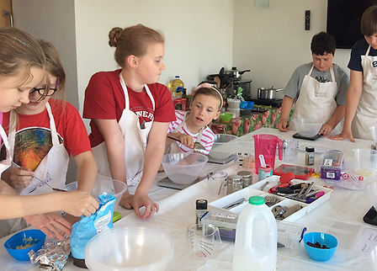

Shinsei Academy - 63 Bell Street, Oldham, OL1 3PY.

Pupils – Age 14-16 (KS4) Shinsei Academy is an alternative provision for pupils in KS4 that have been excluded from school or are at risk of permanent exclusion. We are based in Oldham (next to Mumps Station). The building has a purpose-built gym for training in. Pupils will learn technique in the morning, complete their academic studies mid-morning and then go into sparring in the afternoon slot. All food, drinks, snacks is provided free of charge for pupils. We offer counselling services, 1:1 tutoring and Mentoring sessions. Uniform to train in and equipment is provided free of charge. All pupils are enrolled on the AQA unit award scheme. For SEN Pupils - We offer 1:1 tuition if necessary and we also have counselling services available for pupils with SEMH. <http://www.shinseiacademy.co.uk>

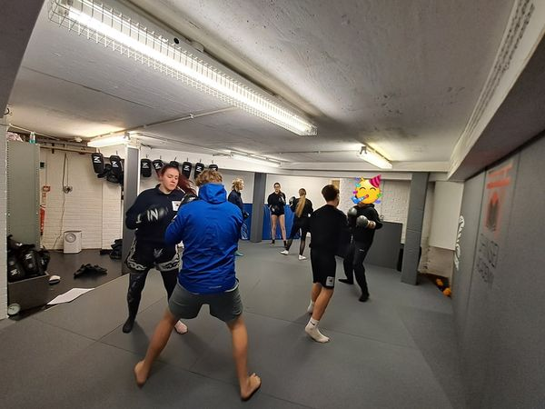

Dream Big – 17 Cobden Street, Chadderton, OL9 9LE

Alternative Provision offer provides young people with a high-quality, tailored and inclusive learning experience. We have the capacity to deliver part-time provision to primary school and secondary school pupils as we aim to support their development, confidence and skills in a supportive environment with fully qualified tutors. <https://dreambigsports.co.uk/>

**Secondary Alternative Provision**

Esteem Educators - Based in libraries or go in schools. The Esteem Educators Mentoring Programme is a creative and inspiring service, offering an individualised 1-2-1 intervention strategy designed to meet the needs of vulnerable young people aged 7-16. We use an interest-led approach to learning with the aim to provide every student with the scaffolding to foster positive aspirations through a curriculum designed around the young person’s interests, enabling them to fulfil their potential in education, employment and life. <https://www.esteemeducators.co.uk/>

Saddleworth Environmental Education (SEE) Based in Delph

Onsite maths and English functional skills, plus mentoring and outdoor learning. **Primary and Secondary pupils are welcome**. SEE also have an independent school based in Shaw. <https://www.seeoldham.co.uk/>

Upturn – 9 Peter St, Oldham, OL1 1HP

1:1 personalised programmes for 14-18 year olds and post 19 in work placements, volunteering, employability, health and wellbeing, visits to employers, possible apprenticeships, maths and English, support with vocational. <https://www.upturn.org.uk/en/>



Path4 Kick Sonic, Waddington Street, Oldham OL9 6QH.

For pupils aged 11-16. The provision is open 10am - 2.45pm for 3 days a week. (15 hours). Their facilities include a sports arena with 2 astro pitches with changing facilities, classrooms, a working car garage where pupils can get real experience and gain a motor vehicle AQA award, they also have opening in January 2025, a small restaurant and kitchen onsite which will be ran as a business to give pupils real life experience and the opportunity to gain a catering AQA. They are building for 2025 a hair and beauty salon and a performing arts studio too. The pupils are taught core subjects of Maths, English, science, IT and humanities in the mornings.

They have the opportunity currently to do functional skills, motor vehicle AQA L1&L2, Social interaction project AQA L1, Art bronze, silver and gold awards, Active Leaders award (CIMPSA accredited), Catering AQA, work experience and volunteering opportunities. https://www.path4.co.uk/

Edstart – Maygate, off Chadderton Way Oldham OL9 6TR

An SEN specialist provision catering for EHCP plans and all young people who are at risk of exclusion. They offer x5 GCSE’s. <https://www.edstartschools.com/oldham/>

**Secondary Alternative Provision**

EK Outreach Services Ltd – Pupils can be taught in their homes or public buildings. Focus on support for SEN young people but are able to support others under the Inclusion umbrella (such as those under YOS, risk of PEX, those not being able to attend a school short or long term etc,.) Can offer ages 5-25yrs. Offer arrange of qualifications, transition work such as functional skills, AQA and A levels. They also use a farm at Northern Roots in Oldham.

<https://ekoutreachservices.com/>

Positive Futures – Positive Steps, Medtia Place, 80 Union Street, Oldham, OL1 1DJ

We are an AQA accredited Centre, and all students will receive AQA’s on completion in all areas. We deliver a variety of practical sessions, in small groups to develop pupils’ life skills, confidence, and self-esteem. Offering a range of meaningful and engaging activities to increase their knowledge and skills, including DIY, Hair and Beauty, Bike Maintenance, Art and Design, Brickwork, Sports and Fitness, Painting and Decorating, Upcycling, Outdoor Project with Northern Roots and dance.

We have a fully functioning hair salon, bike workshop and dance studio.

<https://positive-steps.org.uk/services/positive-futures/>

**Secondary Alternative Provision**

# Chances Mentoring - 3 Whitegate Business Centre, Oldham, OL9 9JT

We offer a therapeutic education to our students delivered by a qualified teacher allowing students to still access high-quality teaching whilst outside of the school environment. Whilst throughout our whole provision mentoring is paramount and a main factor in the work we do. Building relationships with our students and understanding what each individual requires to be a success is what we pride ourselves on.

Our main areas we cover in education are Maths, English, PSHE and where appropriate ASDAN Qualifications

by doing this it allows for our students to succeed within education and achieve accredited qualifications whilst gaining skills in preparation for post-16.

​We undertake a variety of assessments such as strength and difficulties, PASS, ACES allowing us to track and develop our students progress providing both school and home with reports.

### Our students access daily physical activity as this supports their mental health and helps develop their ability to concentrate within the classroom. We invite in guest speakers and go out regularly in the community for outdoor learning or work experience to widen the students’ knowledge and build on their life skills.​ <https://www.chancesmentoring.com/> Contact email [info@chancesmentoring.com](mailto:info@chancesmentoring.com)

**Alternative Provision Out of Borough**

* 0161 Project in Manchester. Offering an alternative education to mainstream schools, working with the most challenging and vulnerable young people in Greater Manchester. Key stage 2. Using boxing and physical activities to develop confidence, discipline, life skills and a positive identity. <https://www.the0161project.co.uk/>
* ACE Training in Rochdale – From Y9 onwards focusing on vocational qualifications in construction, motor vehicle and Hair and beauty. <https://www.acetrainingrochdale.co.uk/>
* APEX - KS3 and KS4 - Apex Specialist Education offers a number of inherent provisions/interventions to meet need. Currently we have 1 (soon to be 2) learning centres in Rochdale. We offer a therapeutic, nurture based academic provision underpinned by rigorous safeguarding, academic, and pastoral structures and expertise. Interventions range from full/part-time, long/short term alternative provision placements. https://apex-specialisteducation.com/
* Communitree in Bury. A forest school for ages 5-15 <http://www.communitree.co.uk>
* Dolled Up Education – ***This is a training provider (not an AP)*** Offers qualifications in Hair and beauty at entry level 3. <https://www.dolledupeducation.co.uk/about-us/>
* Edforall – Offers English and maths functional skills, 1:1 mentoring sessions, anger management and emotional regulation sessions. <http://www.edforall.co.uk>
* Life Changing Education (LCE) in Rochdale. Y5 & 6, KS3 & KS4 – On site at Castleton Soccer Factory focusing on re engagement and re-integration. Mentoring alongside vocational and qualifications. <https://lifechangingeducation.co.uk/>
* Glam Academy in Manchester. Fully approved VTCT training centre, offering, in particular learners aged 14-16 who may not be attending school, have an EHCP plan or not accessing education a VRQ level 2 Skills Award in Hair and Beauty, along with an introduction to mental health awareness course. <http://www.glamacademy.co.uk>
* Skills 4 all – Rochdale. Skills 4 All is an award-nominated STEAM* community organisation based in Rochdale. Based just off the A327 in Castleton, we offer unique and holistic digital-first projects that not only complement and enhance the national school curriculum but also offer young people the chance to learn valuable digital skills and increase employability. From coding and robotics to film-making, social media and mental health sessions, our programmes give under-served young people the chance to experiment with digital technology and encourage them to confidently step into one of the fastest growing industries in the world. <https://skills4all.org/>
* Teenage Kicks – Manchester. Our school, situated in Failsworth, intends to meet the needs of all young people that have perhaps needed a change from a mainstream education. We offer SEMH support and a fresh start to each pupil’s journey and provide a holistic approach in doing so. Teenage Kicks offers an array of subject areas whereby pupils can obtain qualifications and have opportunities to develop and progress to their maximal potential.
* We offer vocational elements within our curriculum, giving pupils experience and a focus to progress at post-16. Vocational aspects to our curriculum include woodwork, barbering and hairdressing and photography. <https://teenagekicks.uk/>
* Tree Of Life, Rochdale. Day centre that provides education to children and young adults, currently not accessing education, for a variety of reasons, but mainly Autism, ADHD and mental health. <https://www.treeoflifecic.co.uk/>

**Alternative Provision Online Providers**

*Please note that the online providers have not been quality assured by Oldham council.*

* Academy21 <https://academy21.co.uk/>
* Prospero <https://www.prosperoteaching.com/>
* Raise tuition <https://raisetuition.co.uk/>
* Targeted Provision <https://www.targetedprovision.com/>